**ABSTRACT**

Among the most common conditions is chronic kidney disease (CKD). major causes of illness and death in medical communities worldwide. Since there are no signs in the initial phases of the disease, patients often misdiagnose chronic renal injury. Critical care kidney disease (CKD) is more common in those living with HIV.Individuals suffering from chronic kidney disease can start therapy sooner and avoid the disease getting worse if they are diagnosed early.The accessibility of pathological information has led leading to a rise in the utilization Various algorithms for machine learning illness a categorization and forecast in the healthcare industry. This study explains how machine learning is used to classify CKD methods.The rate at which glomerulus filters is another factor used to assess the CKD stages in patients. More accurately, the DNN paradigm classifies with 99%.

**CHAPTER-1**

**INTRODUCTION**

**1.Introduction**

Irreversible kidney disease known as renal disease that is chronic (CKD) increases the possibility of several other conditions, such include bone fractures, anemia, and heart failure. The kidneys are highly flexible organs. However, indications of kidney injury will not appear right away. Patients frequently don't show any symptoms till the very end of their sickness. The prevalent signs of a number of illnesses are depicted in Figure 1. Avoiding the symptoms of certain forms of kidney illness can help regulate the condition. Patients can slow down the instruction of their condition by partially restoring their renal function. Kidney transplants and dialysis are the two main treatments for end-stage kidney disease, particularly in patients with congestive kidney illness (CKD). Just 10% of patients globally acquire a dialysis or a similar treatment because of the exorbitant expenses.

This research has investigated machine learning methodologies and completed Automated computer-aided diagnosis (CKD) uses the Support Vector Computer (SVC) algorithm to identify and predict individuals who are diabetic or pre-diabetes based on information on the patient, including age, blood pressure, and test results. The findings show that by utilizing the neural network that uses probabilities, or PNN Naïve Bayes, and decision-making tree algorithms in order to forecast the development of cardiac disease,

SVM able to differentiate between those who have common conditions.It generates superior results compared to other cardiovascular prediction methods. The findings demonstrate considering the Multilayered Perceptron (MLP) separator provides accurate liver disease prediction, particularly in those suffering with liver failure who are associated to HBV. Hepatic cirrhosis caused by HBV was predicted using the MLP separator. computer-assisted, automated CKD

**CHAPTER-2**

**LITERATURE REVIEW**

### 2.1. Present issues and new barriers in the chronic renal illness of HIV-positive people: Heron Jack Edward and Gracey David M.

The condition known as chronic kidney disease (CKD) is a comorbidity of considerable clinical relevance between HIV-positive individuals (PLWHIV) It is connected to a notable rate of illness and mortality. renal disease that is chronic is becoming more common despite the widespread use of antiretroviral medication (ART), and it is increasingly associated with antiretroviral toxicity and common non-infectious comorbidities (NICMs). There are distinct variations, with the highest occurrence of CKD among PLWHIV found on the African continent. The causes of renal illness in individuals living with HIV include complicated immune illness, typical HIV-associated nephropathy, renal disease linked to antiretroviral toxicity, and NICM.

**2.2 A Diagnostic Methods for Treating Chronic Kidney Disease Using Machine Learning: Bin Chen**

A major worldwide health concern, chronic kidney disease (CKD) has An elevated incidence of both illness and death and can lead to other illnesses. Patients sometimes are unaware of their CKD because The illness shows no signs of overt signs in the initial phases. Patients with early-stage chronic kidney disease (CKD) can benefit from prompt treatment to slow the illness's progression. Because machine learning models execute identification tasks quickly and accurately, they can help therapists accomplish this goal. In this work, we suggest a machine learning approach to CKD diagnosis. The California Institute of Technology, Irvine (UCI) machine learning repository provided the CKD data set, which contains a significant amount of missing values.The missing values were filled in using KNN imputation, which chooses a few full samples with the most comparable measurements to process each incomplete sample's missing data. Since patients may overlook certain measurements for a multitude of causes, missing data are typically observed in actual healthcare situations. Six algorithms for machine learning (feed forward neural network, Additionally, logistic regression, random forest, and k-nearest neighbor naive Bayes classifier) were employed to build models after the incomplete data set was successfully filled in. With a diagnosis accuracy of 99.75%, random forest outperformed the other machine learning models. We developed a comprehensive model that uses a perceptron to combine using random forest and logistic regression to analyze the errors in judgment produced by the models that are in use. This model may produce an average analyze the errors in judgment made by the existing models. This model may produce an average

### 2.3. Classifying Chronic Kidney Disease Using Wide and Deep Learning, Feedforward Neural Networks, and Logistic Regression

Approximately 10% of adults Chronic kidney disease (CKD) affects people all over the globe.a burden on global health. It is recognized as one among the leading 20 reasons for demise worldwide. Chronic kidney disease (CKD) has no known cure, however early detection of the illness can lessen damage and delay the disease's course. Because of a deficiency in nephrologists, most of patients typically do not acquire an early detection of kidney illness (CKD) in chronic patients. Thus, modern computer-aided techniques must be applied to raise the effectiveness and precision of the traditional CKD diagnosis system. Our main goals in this investigation were to diagnose CKD utilizing three modern machine learning techniques: logistic

**2.4. Existing System:**

Studied the connection between even worse consequences and chronic renal disease. Angiotensin receptor blockers and The use of inhibitors of the angiotensin converting enzyme shown in studies to lower blood pressure and slow the development of kidney disease (CKD) over time in HIV patients, particularly in situations where proteinuria is evident. demonstrates the viability of Improving data and diagnosing a sample in CKD. To reach the necessary level of precision for the integrated model that is shown in this study, the KNN technique can be applied. Given that the dataset only contains two classes Chronicle Lack of Chronic Kidney Disease and Infection the model is unable to evaluate the phases of long-term renal damage

makes use of a lab dataset containing 361 persistent kidney disease patients. The length of chronic renal illness is ascertained using The MLP, SVM, and PNN algorithms. With this information, the probabilistic neural. organization algorithm is the most effective tool that doctors may employ to reduce diagnostic and treatment errors. Utilizing logistic regression and feed forward neural networks, compare the performance of the model on real (imbalanced) data versus the model on oversampled (balanced) data. Feed forward neural networks demonstrated both actual and oversampled data the best performance, containing 0.99 AUC, 0.97 Precision, 0.99 F1-Score, and 0.99 Recall. K. S. Vaisla, N. Chetty, and S. D. Sudarsan et al. gave it their advice. Models for assessing and categorizing attributes were used.

## 2.4.1. Disadvantages

* The The Multilayer Perceptron (MLP) separator not used to predict HBV-induced hepatic cirrhosis, and the results show that the MLP separator provide exceptional liver disease prognostications, especially for individuals with liver failure connected to HBV. The system lacks a method to find CKD stage identification.

## 2.5. Proposed System:

The literature categorizes CKD using a range of machine learning techniques. To ascertain if a The patient suffers from chronic renal disease. or not, we have built six machine learning frameworks in this work: a deep neural network using the methods of xg-boost, ada-boost, random forest, KNN, and SVM. The proposed experimental setup's flow is depicted in Figure 2. Support vector computers, commonly referred as as SVMs, are binary classification scenarios' application justification for machine learning under supervision models based on classification. The K-nearest neighbors (KNN) technique compares features to forecast a rating determined by how It's comparable to the training dataset. Decision trees are used to graphically depict categorization decisions. It occurs often not possible to attain efficient classification accuracy with a single decision tree.

The AdaBoost an algorithm is a type of machine learning ensemble technique for boosting; it is additionally referred to as adaptive boosting. It aims to create a strong classifier from a set of weak ones by assigning a new weight to each occurrence. XG Boost (eXtreme Gradient Boosting) is another boosting strategy that utilizes a gradient boosting architecture. To achieve better categorization results, numerous researchers have mixed artificial intelligence with feature- based deep neural networks (DNNs). Deep neural networks are able to recognize significant illnesses because they employ several layers of nodes to carry out high-level operations on incoming data. Prior to applying the classification algorithm, we utilized The feature selection process to eliminate a couplefeatures.

## 2.5.1 Benefits:

* Recursive Feature Elimination,, or RFE, is based on well-liked characteristics selection method which chooses the training dataset's features (columns) that are more important for estimating the desired variable.
* The automated computer-aided diagnosis process uses patient data, for example, blood pressure, age, and test findings, in order to ascertain the state of CKD. has identified and predicted patients with diabetes and prediabetes using the Support Vector Computer (SVC) approach.

**CHAPTER-3**

**SYSTEM DESIGNS**

**3.1. Algorithms:**

Identifying the ascertaining stage of long-term renal illness in persons who test positive for HIV, the following algorithms are employed:

1. The K-Nearest Neighbors (KNN) Algorithm

2. Logistic Regression Algorithms

3. The Algorithm of Random Forest

4. Linear Form Support Vector Machine (SVM)

**3.1.1. Algorithm K-Nearest Neighbors (KNN):**

* Predicted on Supervised Learning approach, K-Nearest Neighbor is among the greatest

basic machine learning algorithms.

* The K-NN technique assigns the new example to the group that most closely corresponds to

the existing categories, presuming that the new instance and data are identical to the cases that already exist.

* A new data point is classified using the K-NN algorithm based on similarity following the collection of all pertinent data saved.
* This implies that the K-NN algorithm can classify new data quickly.
* The K-NN technique can be applied to regression issues, but it is primarily employed to classification challenges.
* The K-NN algorithm lacks parametricity, which implies it doesn't make any presumptions about the data it uses. ➢Another name for it is a lazy learner algorithm since it continues to

**3.1.2. Logistic Regression Algorithms:**

Regression is An easier, more effective way to classification issues that are binary and linear. It's a straightforward classification model that works incredibly well has classes that can be divided linearly. This approach is frequently used in the industry for classification. Logistic regression analysis is used to look at the relationship between a collection of independent (explanatory) variables and a categorical dependent variable. The purpose of logistic regression is use.

when There are just two in the dependent variable values, like 0 and 1, or Yes and No. The term multinomial logistic regression is often saved for circumstances where the dependent variable (married, single, divorced, or widowed) has three or more distinct values.Considering the type of data used for.

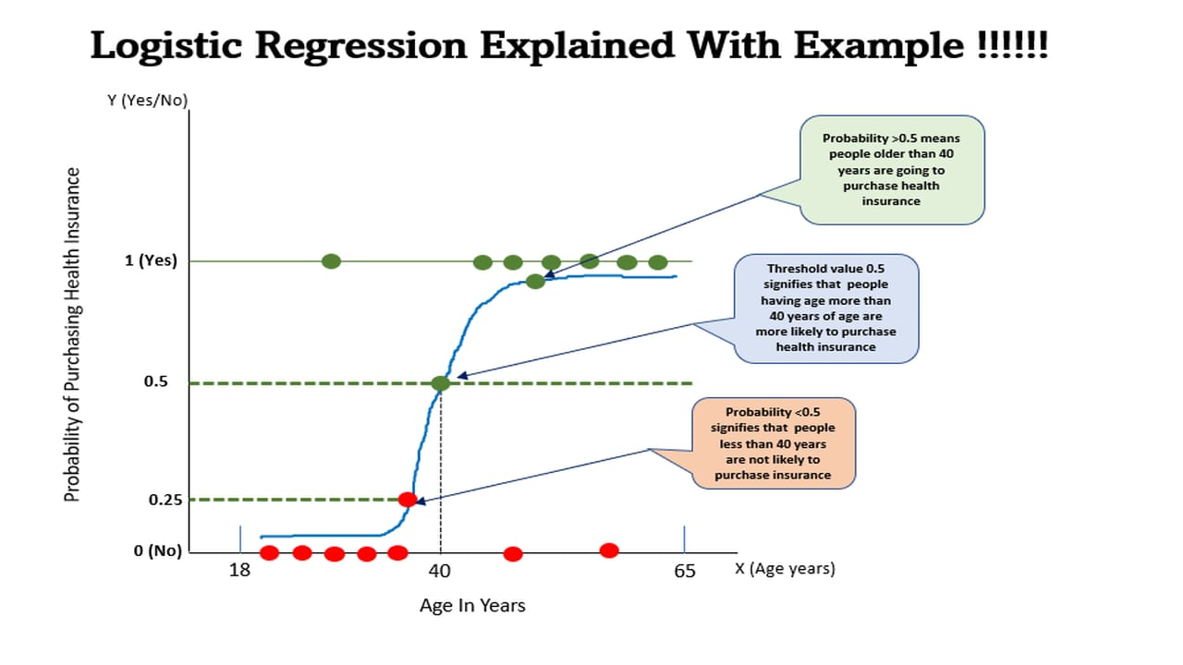

**Fig 1**: Logistic Regression

**3.1.3. Random Forest Algorithm:**

Random forests, another name for random decision forests, are an approach to group learning that create a lot of decision trees during the instruction stage for tasks like classification and regression. Using the random subspace method, Tin Kam Ho implemented Eugene Kleinberg's "stochastic discrimination" approach to classification and created the first random decision forest algorithm in 1995. A trademark application for "Random Forests" was made in 2006 by Leo Breiman and Adele Cutler, who expanded the algorithm. As of 2019, Minitab, Inc. is the proprietor of this trademark.This expansion combines random feature selection, first introduced by Amit and Geman and later independently, with Breiman's "bagging" idea to create a set of decision trees with controlled variance.

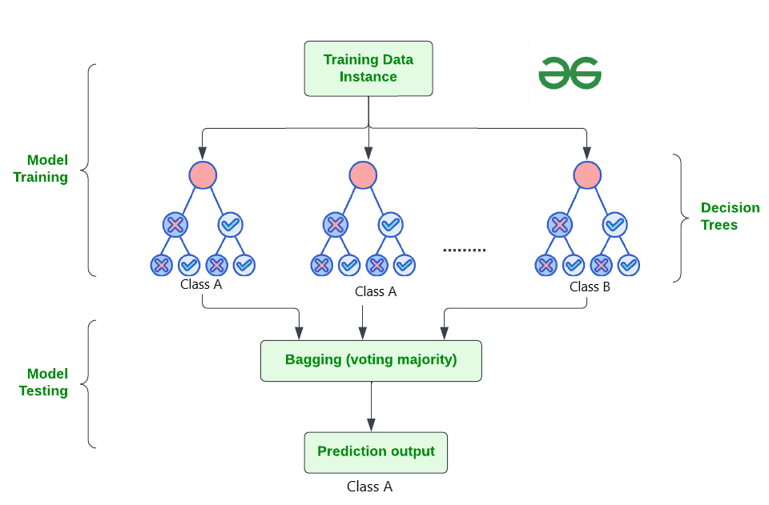

**Fig2:**Random Forest Algorithm

**3.1.4. Linear Support Vector Machine(SVM):**

Support Vector Machine (SVM) is a machine learning under supervision method It could be used for both regression and classification. However, classification issues are most appropriate for using regression problems. The fundamental goal of the SVM approach is to find the best hyperplane in an N-dimensional space to divide data points into various feature space classes. The intention of the hyperplane is to keep up the largest possible buffer between the nearest points of various classes. The hyperplane can be viewed as a line when the number of input characteristics is two. The hyperplane transforms into a 2-D plane if all three input features are present. It turns into

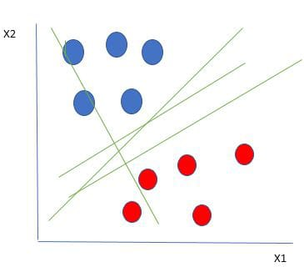

**Fig3**:Support Vector Machine

The accompanying figure makes it very evident that our data points are divided into red and blue circles by a number of lines (in this example, our hyperplane is a line because we are only considering two input features, x1, x2).

**3.2. System Architecture:**

HIV-positive people's chronic kidney disease (CKD) stage can be determined using machine learning.The following is a summary of the standard architectural design for this kind of system: Collect information from many sources., including imaging studies, laboratory results, electronic health records (EHR), patient demographics, HIV-specific information, and any other relevant clinical data.Deal with errors, data inconsistencies, outliers, and missing numbers. This phase is crucial to ensure the quality of the dataset.

•

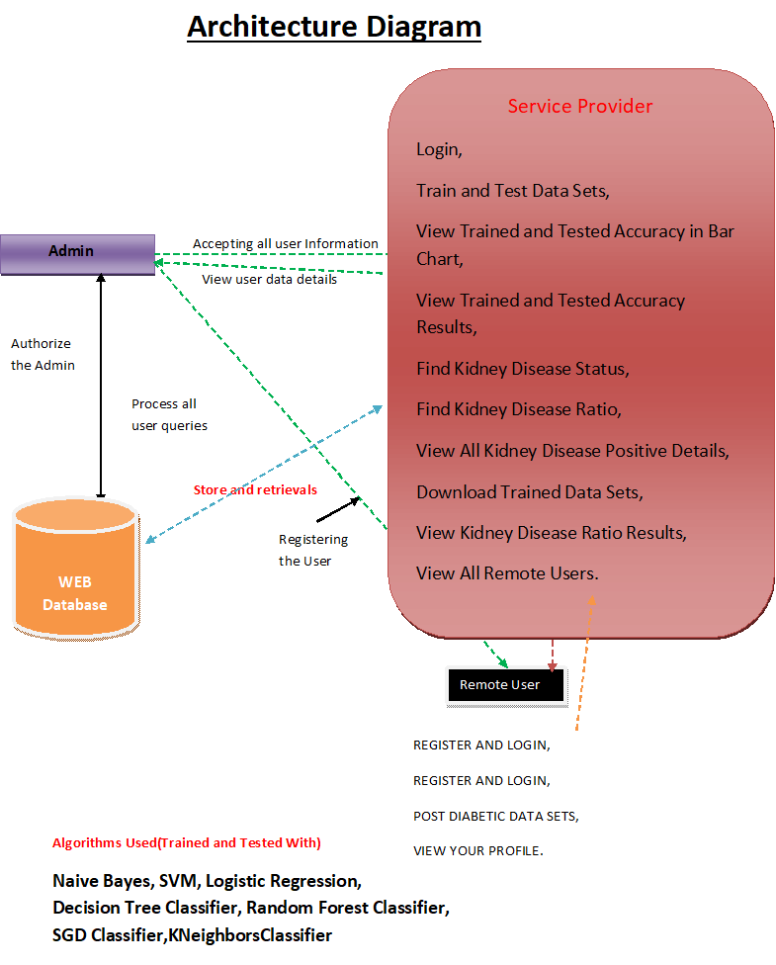

**Fig 4:** System Architecture

Select approaches for machine learning that are suitable for problems involving classifiction. Gradient boosting machines (GBM), artificial neural networks (ANNs), Support vector machines (SVM), decision trees, and random forests, and logistic regression are widely used methods for diagnosing the stage of chronic kidney disease (CKD). To guarantee the model's clinical relevance and accuracy, domain experts such as nephrologists, HIV specialists, and data scientists must be included at every stage of the development process.

**3.3 Life Cycle of Software Development:**

Software Development Life Cycle is referred to as SDLC.This method is used by software companies to produce software. A thorough approach that describes the software development process, including how to build, modify, oversee, and generate different models within the life cycle of software development is called the Life Cycle of Software Development (SDLC). "Software Development Process Models" is a common term for

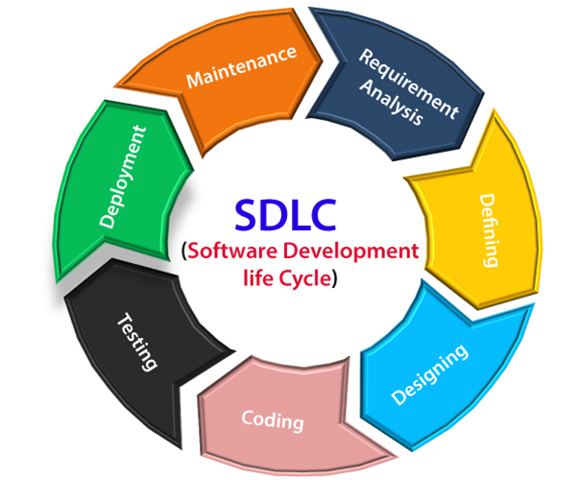

**Fig 5**:SDLC Model

Each process model follows a set of phases unique to its kind to ensure success at every level Describing the procedure for developing software. Among them are spiral, incremental, RAD, waterfall, and iterative models. Out of all these models, the spiral model works the best.

### Spiral Model:

It integrates design components with iterative prototyping, so combining the advantages of bottom-up and top-down methodologies. This headway concept combines the qualities of the prototyping model and the fountain model. The winding model is recommended for large-scale, high-cost, and intricate applications. This specific model

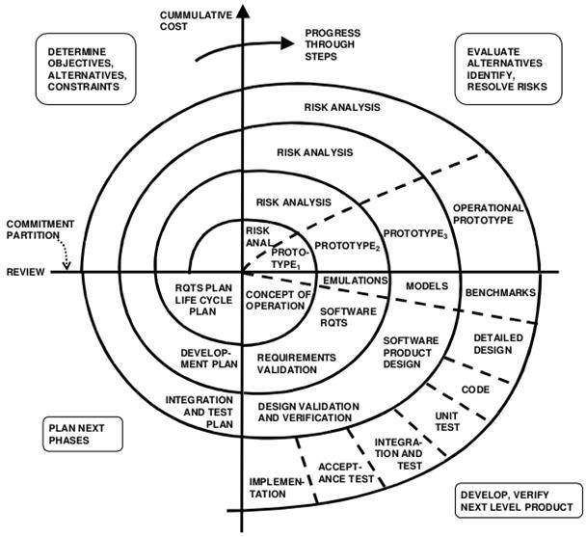

**Fig 6:**Spiral Model

**3.4. Feasibility Study:**

Determining if the system request is possible is a crucial result of the preliminary inquiry. Only if it is doable with the time and resources available will this be viable. The several feasibilities that need to be examined are:

* **operational Feasibility**
* **Economical feasibility**
* **Technical feasibility**

**3.4.1: Operational Feasibility:**

Operational feasibility is the analysis of the system's potential that has to be developed. Operationally, this approach relieves the administrator of all his stress and assists him in efficiently monitoring the project's advancement. There is no doubt that this type of automation will save the effort and time that were formerly dedicated to manual labor. The analysis demonstrates the operational viability of the system

**3.4.2. Economic Feasibility**

An assessment of the monetary case for a computer-based project referred to as cost-benefit analysis or economic feasibility. The hardware project had a cheap cost because Hardware was set up by the start and served many tasks An infinite amount of workers linked to the organization's This utility is available to local area networks (LANs) at all times. because it is network-based. The organization's current resources will be used to construct the virtual private network. Therefore, the proposal is financially viable

**3.4.3. Technical Feasibility**

Technical feasibility, based on Roger S. Pressman, is the assessment of the organization's technical resources. The company requires PCs that are compatible with IBM that are linked to the Intranet and Internet using a graphical web browser. The framework is designed to operate in a platform-independent setting. The framework is is developed using Java Server Pages, JavaScript, HTML, SQL Server, and WebLogic Server. The technical viability analysis has been completed. The system can be created using the current facility and is technically possible.

**3.5. Needs Analysis:**

A need is a factual statement that is often brief also to the point. It might be expressed using a visual of some sort or It might be written as a sentence.

**3.5.1. Functional Requirements:**

These specify the functions that the system must perform. The following categories might become accustomed to further group the functional requirements: The interface between the user and Designing the input is what the information system does. It includes creating specifications and guidelines for data preparation moreover,the steps necessary to transform transaction data into a format that can be processed. This achievable by having users enter data directly into the system or by having computers read data from written or printed documents.

**3.5.2. Non-functional Requirements:**

Coming up next are the chief kinds of non-useful necessities:

Non-Functional Requirements address principal issues of huge worth for programming structures. If NFRs not tended to true to form, the results can include:

* + - * Clients, clients, and creators are unsatisfied.
      * Clashing programming.

Time and cost overpower to fix what which was prepared without reviewing NFRs.

**Types of Non-functional Requirements:**

1. Scalability
2. Reliability
3. Regulatory
4. Maintainability
5. Serviceability
6. Utility
7. Availability
8. Usability
9. Interoperability
10. Environmental

**3.6. Modules:**

**3.6.1. Service Provider:**

To access this module, the Service Provider needs to provide a working user name and password.Following a successful login, He'll have the ability to perform a several tasks, including Finding Kidney Disease Status, Finding Kidney Disease Ratio, Viewing All Kidney Disease Positive Details, Downloading Trained Data Sets, Viewing Kidney Disease Ratio Results, and Viewing All Remote Users

**3.6.2. View and Authorize Users:**

This module allows the administrator to see a list of all enrolled users. In this, the administrator may see user information such name, email address, and address, and they can also approve people.

**3.6.3. Remote User:**

This module contains an integer number of users.

**3.7. Unified Modeling Language (UML) Diagram:**

Among the following list, four fundamental UML diagrams have been explained in the project:

* class diagram
* sequence diagram,
* use case diagram,
* Flow chart diagram,

**3.7.1. Class Diagram:**

A Kind of static structural diagram used A class diagram in software engineering using the Unified Modelling Language (UML) illustrates the classes, properties, and relationships inside a framework to explain its structure. Among the developing diagrams, this one is the greatest significant. Three levels make up the class based on the diagram. There are connections made between the classes. To create classes, developers utilize the Class Diagram. Analysts utilize it to display the system's details.

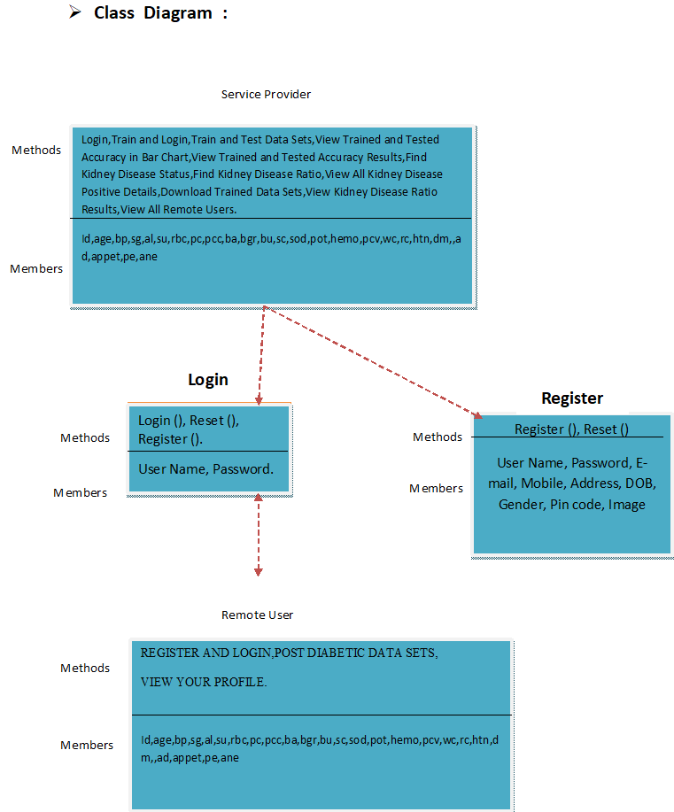

**Fig 7:**Class Diagram

**3.7.2. Sequence Diagram:**

Using the Unified Modelling Language (UML), One kind of interaction diagram that is used is the sequence diagram. illustrates the sequence and manner where in processes communicate with each other one more. This structure is a Message Sequence Chart.Event-trace Sequence diagrams can also be known as event scenarios, timing diagrams, or diagramming.

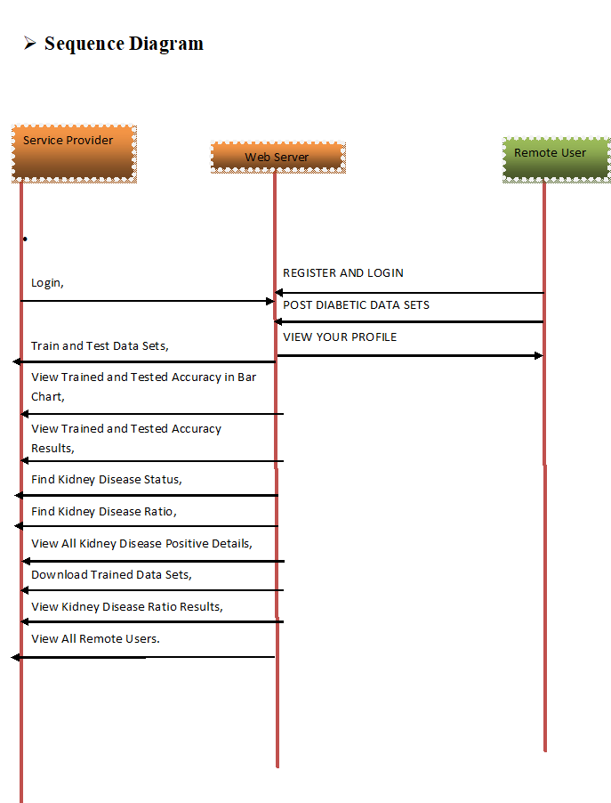

**Fig 8:** Sequence Diagram

**3.7.3. Use Case Diagram:**

In software engineering, A use case illustration is a kind of the behavioral schematic that is produced from and defined by a study of use cases. It is described by UML stands for Unified Modelling Language. Its objective is to offer a visual representation of the functionality that a system offers in terms of actors, use cases (representations of their goals), and how such use cases are interdependent.

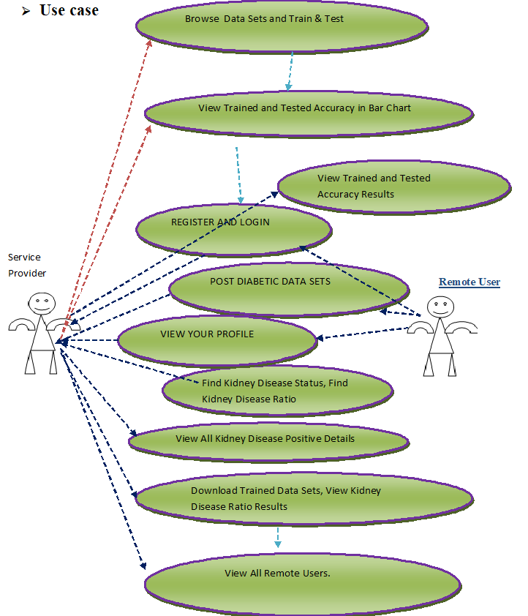

**Fig 9:** Use Case Diagram

The main purpose of An illustration of a use case is to show which actors are able to access which system features. The roles of the actors in the system can be illustrated. During requirements elicitation and analysis, use cases reflect the functionality of the system. Use cases focus on the behavior of the system from an external perspective.

**3.6.4. Flow Chart Diagram:**

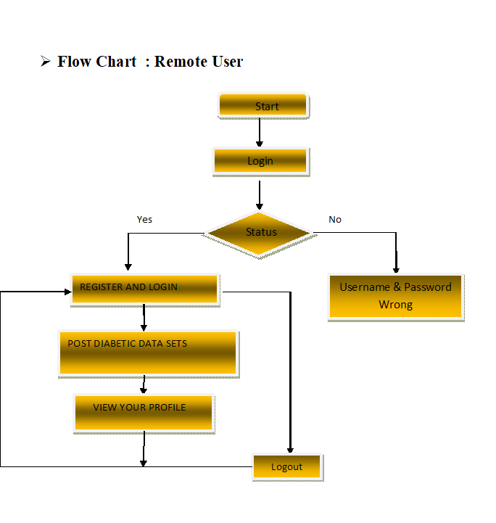

**Fig 10**:Remote User

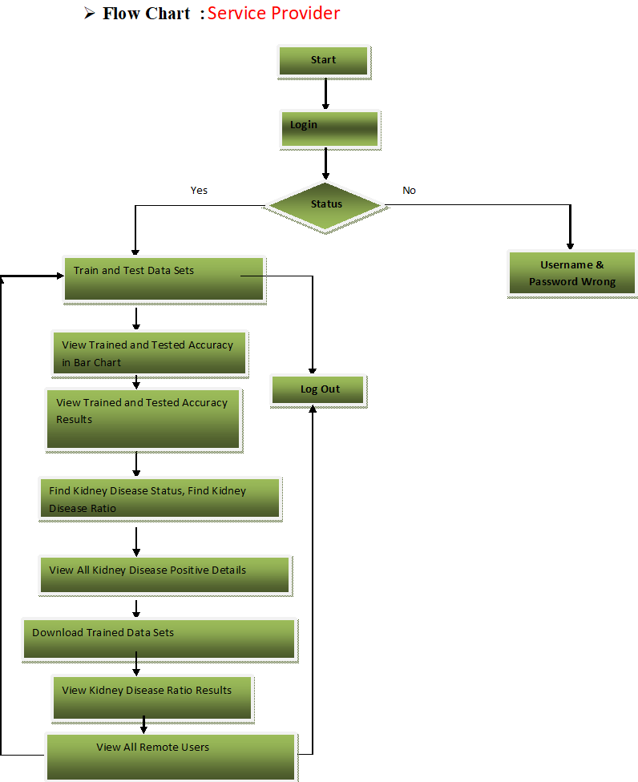

**Fig 11:**Service Provider

**CHAPTER-4**

**IMPLEMENTATION**

**4.1. Programming Language:**

**4.1.1. Overview of Python:**

Given that Python is object-oriented, high-level, general-purpose, interpreted programming language. Python is a language that is interpreted.with a syntax that lets programmers express ideas utilizing less code lines than they might in languages like C++ or Java. It prioritizes coding in its design philosophy readability, most notably by using whitespace indentation to delimit code blocks instead of curly brackets or keywords. It offers building blocks that facilitate understandable programming at both small and large sizes. There are interpreters for Python on a wide range of operating systems. C Like almost all of its variant implementations, Python, the reference implementation, is an open source program with a community-based development process. The nonprofit Python Software Foundation is in charge of overseeing CPython. It boasts an extensive and well-rounded standard library and supports a variety of programming paradigms, including as imperative, functional, procedural, and object-oriented

**4.2. APPLICATIONS OF PYTHON**

Python is one of the languages that is most frequently used online, as was previously noted. Here is a short list of some of the them:

1. Simple structure, minimal number of keywords, and well-defined Syntax makes Python a simple

language to learn. The learner's quick language acquisition is facilitated by this.

2. Easier to read: Python programming has higher readability and visually appealing.

3. Easy to maintain – The source code of Python is not too difficult to maintain.

4. A large standard library: The majority cross-platform compatibility with Python's library Addition ally, it runs quite well on UNIX, Mac, and Windows platforms.

5. Interactive Mode: Python includes a style of interaction that permits interactive debugging and testing of small code fragments.

6. Portable – Python has an identical a wide variety of hardware systems can interface.

7. Extendable − The Python interpreter can add lower-level modules to it. These modules can be improved upon or changed by programmers to increase the power of their tools.

8. sDatabases: All of the major There are interfaces accessible in commercial databases in Python.

9. Programming Graphical User Interfaces − Python allows the development of GUI applications and their translation to a range of system calls, libraries, and Windows platforms, such as the Macintosh, Windows MFC, and X Window system of Unix.

10. Scalable — Python provides greater resources for larger applications. structure and support than shell scripting does.

**4.3.Data Sets:**

**4.3.1. UKC_JSI Datasets:**

The UKC_JSI dataset offers a useful chance to use machine learning methods to The prognosis of HIV-positive patients' phases of long-term renal illness . Researchers and Physicians can utilize this dataset to create predictive models that help with early diagnosis and treatment of CKD in this particular patient population.

Let's take an example where a group of academics wants to use the UKC_JSI dataset in order to build a machine learning model capable of predict the phases of long-term renal illness. in patients who have HIV. They do exploratory data analysis to determine the correlations between different clinical characteristics and CKD stages after obtaining and preparing the dataset. It is perhaps that they will find out relationships between variables like renal function indicators, drug history, CD4 count, and viral load.

After that, they choose suitable machine learning techniques to train their models, such as decision-making support vector machines trees, and logistic regression. After dividing the dataset into training and testing sets, they use the training data to train the models and assess their effectiveness using measures such as F1-score, accuracy, precision, and recall.

The researchers optimize the models for CKD stage prediction by fine-tuning hyper parameters through iterative model training, evaluation, and validation. Eventually, they implement the model that performs the best into clinical settings, where it can assist healthcare providers in identifying patients that pose a danger of developing chronic kidney disease (CKD) and start early therapies.

**4.3.2. Physionet Dataset:**

Researchers and practitioners looking to make advantage of machine learning strategies to determine the phases of long-term renal illness in HIV-positive patients will find the PhysioNet dataset to be a valuable resource. PhysioNet is an important source of information for investigating intricate correlations between clinical variables and the advancement of chronic kidney disease (CKD) in this particular patient population since it provides a wide variety of physiological information compiled from several sources, such as research studies and clinical settings.

As an illustration, consider a research group that wants to use the PhysioNet dataset to build an artificial intelligence model for HIV-positive patients' CKD stage detection. Their initial step involves gaining access to the dataset and performing pre-processing, which may involve encoding categorical variables, addressing missing values, and normalizing features. The collaborates to conduct exploratory data analysis utilizing the pre-processed data to find patterns and connections between indicators of renal function, such as serum creatinine levels and measured GFR (glomerular filtration rate) and clinical parameters, such as the amount of virus, CD4 count, and medication history. Features are chosen and models are developed based on insights obtained from this study.

In order to create prediction models, the researchers try out several machine learning methods, such as neural networks, logistic regression, random forests, and gradient boosting machines. After dividing the dataset into training, validation, and testing sets, they use the training data to train the models and employ grid search and cross-validation to fine-tune the hyper parameters.

**CHAPTER-5**

**SYSTEM TESTING**

**5.1. Testing and Validation:**

The procedure for finding errors called testing. Testing is completed to find any potential vulnerabilities or flaws in an output of work. It offers an evaluation method for the functionality of individual components, assemblies, subassemblies, and/or finished goods. It involves testing software to ensure that it meets standards for users and expectations and doesn't act inappropriately. There are numerous varieties of tests. Every kind of test satisfies a certain testing requirement.

**5.2. Methods for Testing:**

The testing procedures are as follows:

**5.2.1. Unit Testing:**

Verification efforts are focused on the module, the software's smallest unit architecture, through unit testing. By exercising particular routes within a module's control hierarchy, unit testing seeks to maximize error detection and ensure complete coverage. By focusing on every module independently, this test determines whether or not It serves as acoherent whole.

Throughout this testing procedure, Every module is tested independently, and the interfaces between the modules are reviewed to ensure they comply with the design criteria. Each and every significant processing step is checked to make sure the anticipated outcomes are achieved. Every path for handling errors is also examined

**5.2.2. Integration Testing:**

This method addresses challenges pertaining to the two issues of program design and verification. Once the program has been integrated, a number of high-order tests are run.

.

1. **Top Down Integration:**

This method builds The framework of the program piece by piece. The modules are connected starting together with the primary software module and moving down the control hierarchy. Subordinate modules of the primary program modules are either breadth-first or depth-first integrated into the framework. using this technique, the software is tested starting with the primary module and progressing below by substituting individual stubs

1. **Bottom-up Integrating :**

Using this method, the building and testing process begins putting the modules at the program's bottom hierarchy. Stubs are not required since the computation necessary for modules beneath a certain Level is constantly accessible because The integrated components originate from the bottom up.

**5.2.3. User Acceptance Testing:**

The adoption of the system by its users is a major factor in its success. The system's acceptability by users is continuously assessed. while it is being created by keeping in constant contact with potential users and making the required adjustments. Because of the system's appealing design, even a non-expert user can easily comprehend the user interface.

**5.2.4: Testing of Output:**

After validation testing is complete, the output of the recommended system must be examined because no system is usable if it cannot generate the necessary output in the right format. Users can be asked what format they require to verify that the system's outputs produces or shows.

**5.2.5 Validation Checking:**

The fields listed below undergo validation tests.

**Text Field:**

We can only enter Characters that fall short of or equal to the size of the text area. The fields with text are either alphanumeric or alphabetical depending on the table. Erroneous input in every case results in the display of an error message.

**Numerical Field:**

In this area, only numbers between 0 and 9 are allowed. An error notice flashes when a character is entered. We check each module for precision and necessary functionality. Every module undergoes test runs using sample data. The independently Examined components are included into a single, coherent system. Actual Information is utilized during testing to ascertain whether the application has any flaws.

**Test Data Preparation :**

A range of test There are data formats utilized. for the aforementioned testing. Preparing the test data is crucial to testing the system. The prepared test data is used to test the system under investigation. When Test data is used to evaluate the system, and mistakes are discovered once more and are corrected using the previously described testing processes. Additionally, The modifications are recorded for the future. reference

**Using Actual Test Data:**

Data from live tests are those that are truly pulled from organization files. Once a system is mostly established, Users are frequently asked by programmers or analysts to enter some information from their daily activities. The systems professional then uses this information to perform a partial system test.

**Using Simulated Test Data:**

Synthetic test results are developed solely for testing reasons since they could be appliedto test any format and value combination. Stated otherwise, the utility that generates data software of The department of information systems can generate fake data quickly, enabling checking of every program's control and login channels. The most successful Artificial tests are used in testing programs. data, supplied by anyone other than the programmers. Testing strategies are often developed by a different group of testers use the platform requirements as a guide. Since the "Virtual Private Network" package complies with every need specified in the software requirement specification, it was accepted

**5.3. Acceptance and System Testing:**

System testing actually entails several processes

**CHAPTER-6**

**FUTURE ENHANCEMENT**

Future advances in techniques based on machine learning can significantly improve the identification of chronic kidney disease (CKD) phases in HIV-positive individuals. Large-scale patient data, including as demographics, kidney function test results, HIV-related metrics, and comorbidities,can be used in order to develop machine learning models thatreliably predict stages of

chronic kidney disease (CKD). These models have the ability to managing the intricate relationships between many clinical factors and During the duration of CKD in HIV-positive persons. They range from logistic regression to more sophisticated algorithms like neural networks. Furthermore, continued research in the areas of feature selection, interpretability, and model validation guarantees that these examples aren't just produce precise forecasts but also shed light on the fundamental variables affecting the course of CKD in this particular patient population.As these machine learning techniques advance, they have the potential to significantly improve HIV-positive patients' early diagnosis, prognosis, and tailored Strategies for managing chronic kidney disease, which would eventually improve clinical outcomes and quality of life

**CHAPTER-7**

**CONCLUSION**

HIV-positive patients' chronic kidney disease stages can be classified to help clinicians make timely and appropriate clinical decisions, which is beneficial to both patients and physicians. In order to classify CKD in HIV-positive patients, we have examined the effectiveness of the newest machine learning techniques are applied in conjunction with DNN. With regard to CKD categorization, DNN has performed better, according on our research. Furthermore, we have shown you how to use the EGFR computation to ascertain the stage of a disease. With the combination of features-based DNN with medical image analysis, diagnosis based on several imaging modalities can be eventually provided.

**CHAPTER-8**

**SCREENSHOTS**

**8.1.Output Screens:**

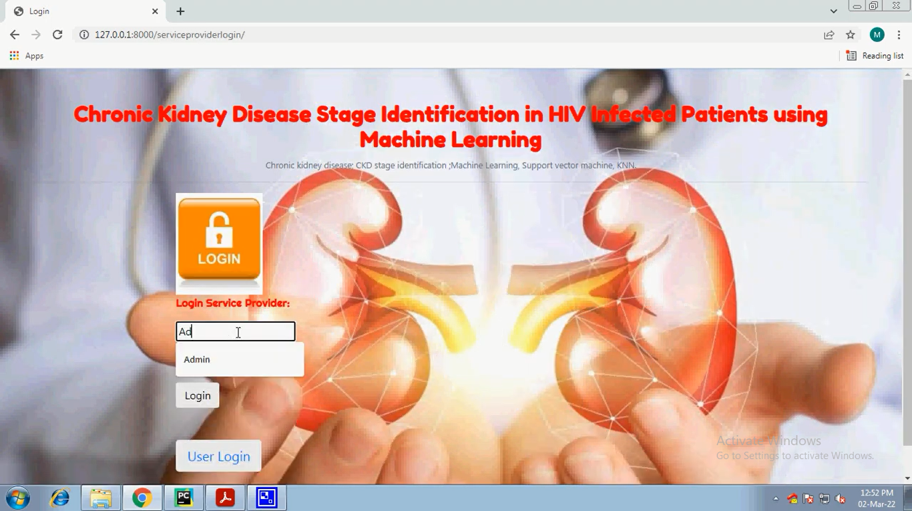

**Fig12**: Service Provider login

A methodical methodology is used by a login service provider for the machine learning-based chronic kidney disease (CKD) stage identification in HIV-positive patients. First, extensive datasets containing demographic information, metrics related to HIV, kidney function tests, and other clinical data are gathered. The data is then cleaned, missing values are handled, and features are normalized using data preprocessing techniques

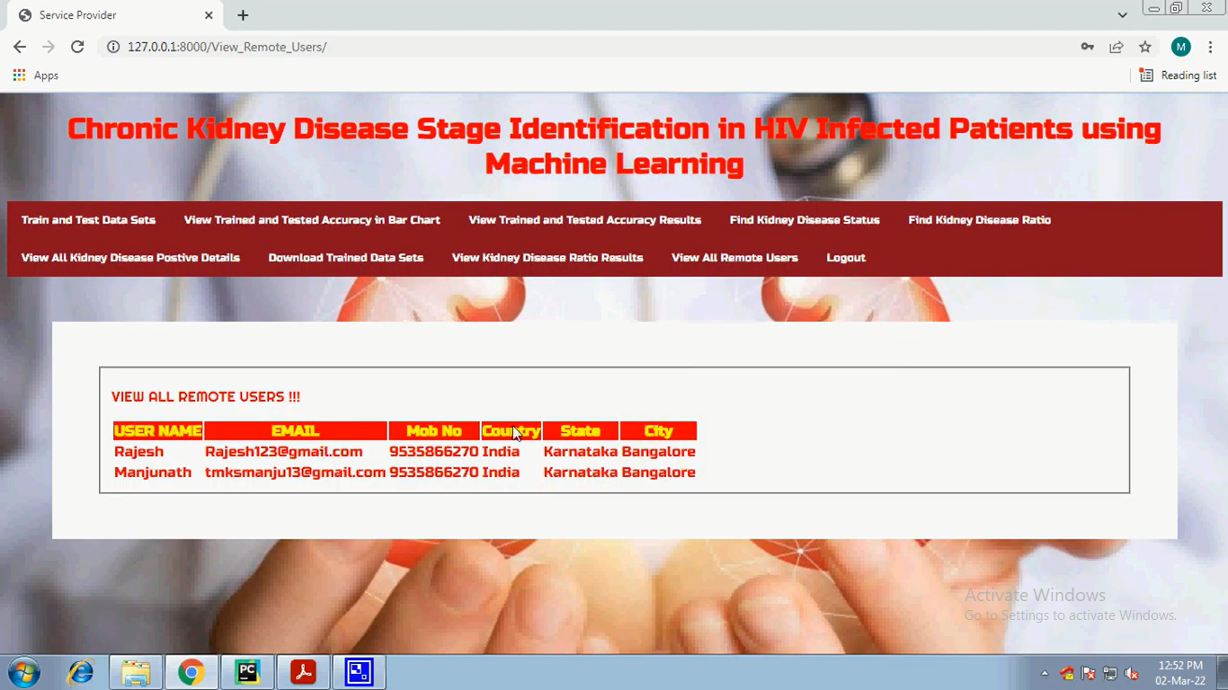

**Fig13:** View Remote Users

User information such as username, email address, mobile number, nation, state, and city can be viewed by remote users.

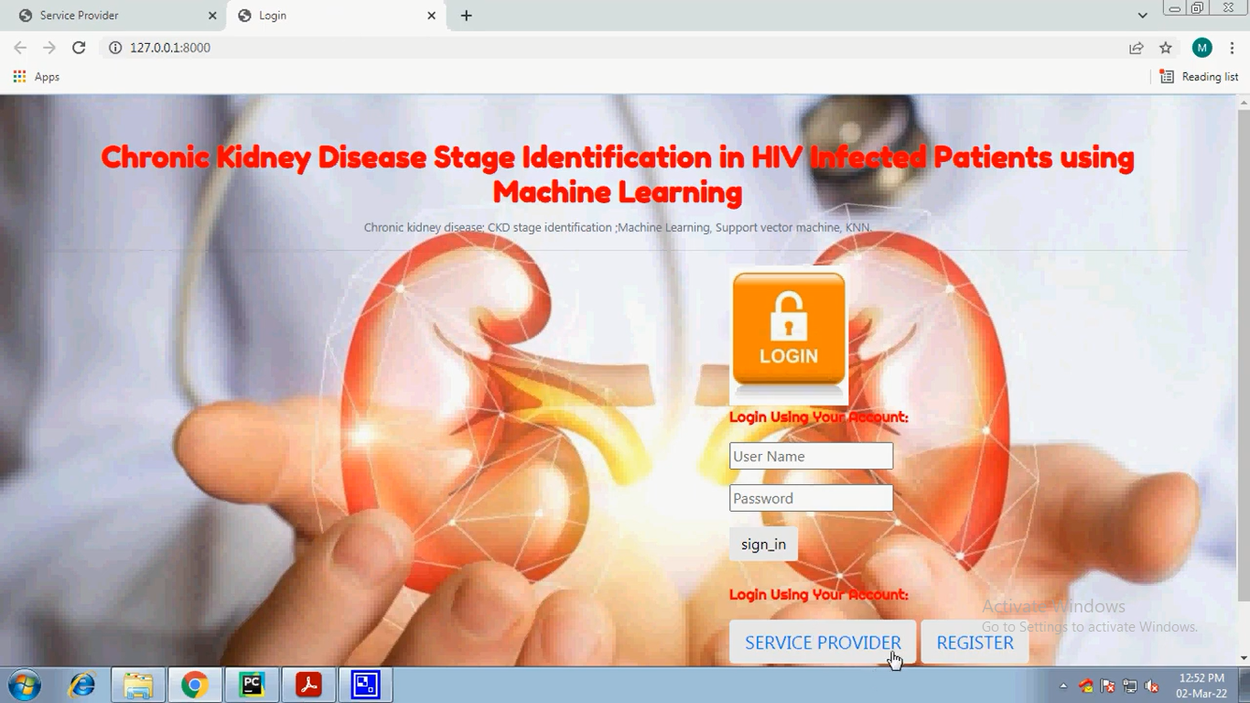

**Fig14**: Account login

The username and password are required for account login before signing in.After that, click on the service provider to access your account.

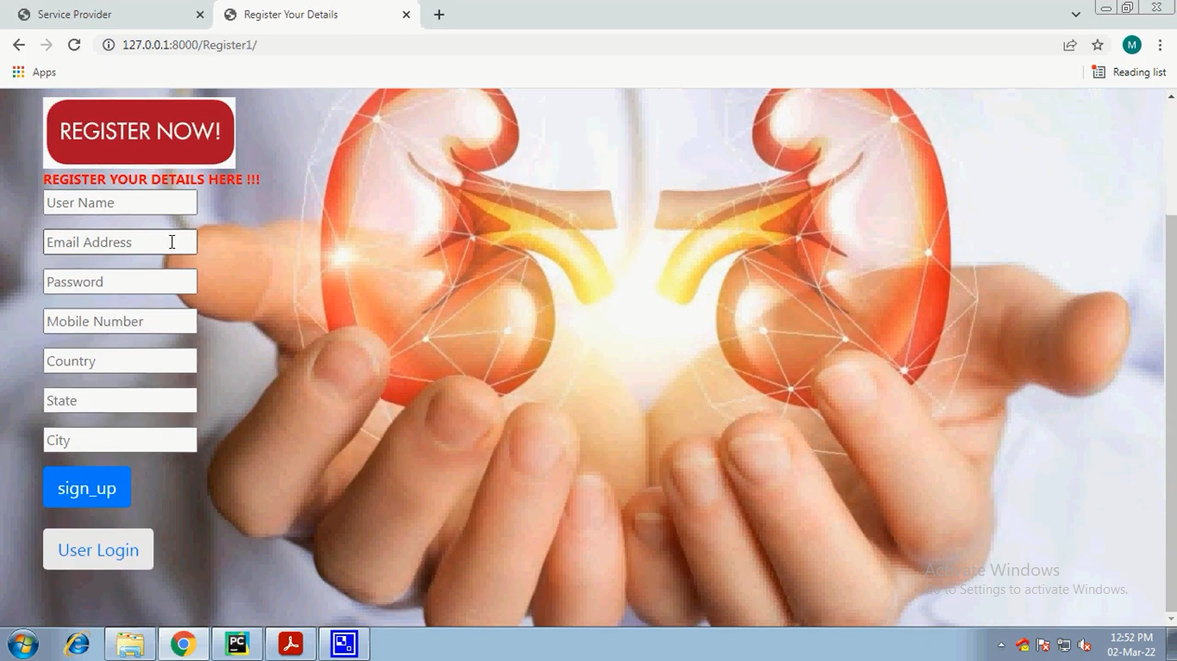

**Fig15**: Register Form

Name, email, password, mobile number, nation, state, and city may all be found on this registration form. After registering, sign up and submit your information

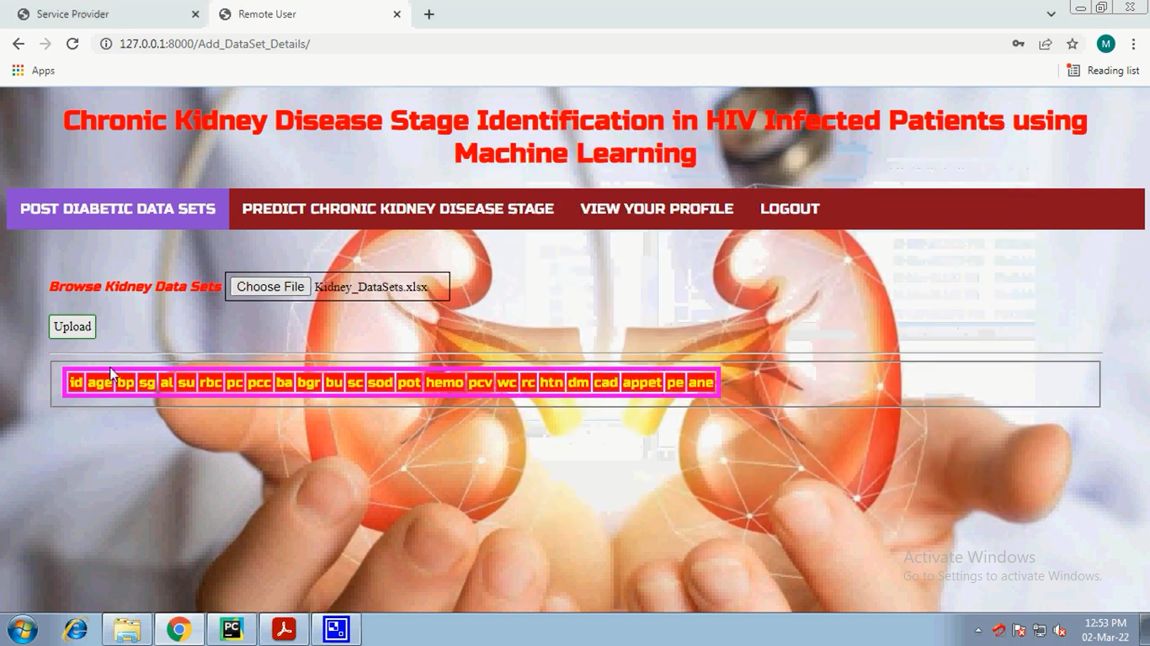

**Fig16**: Dataset_details

After registering, open the dataset details, select the renal data sets from the browse tab, click "Choose File," enter the patient information and reports, and upload your file//

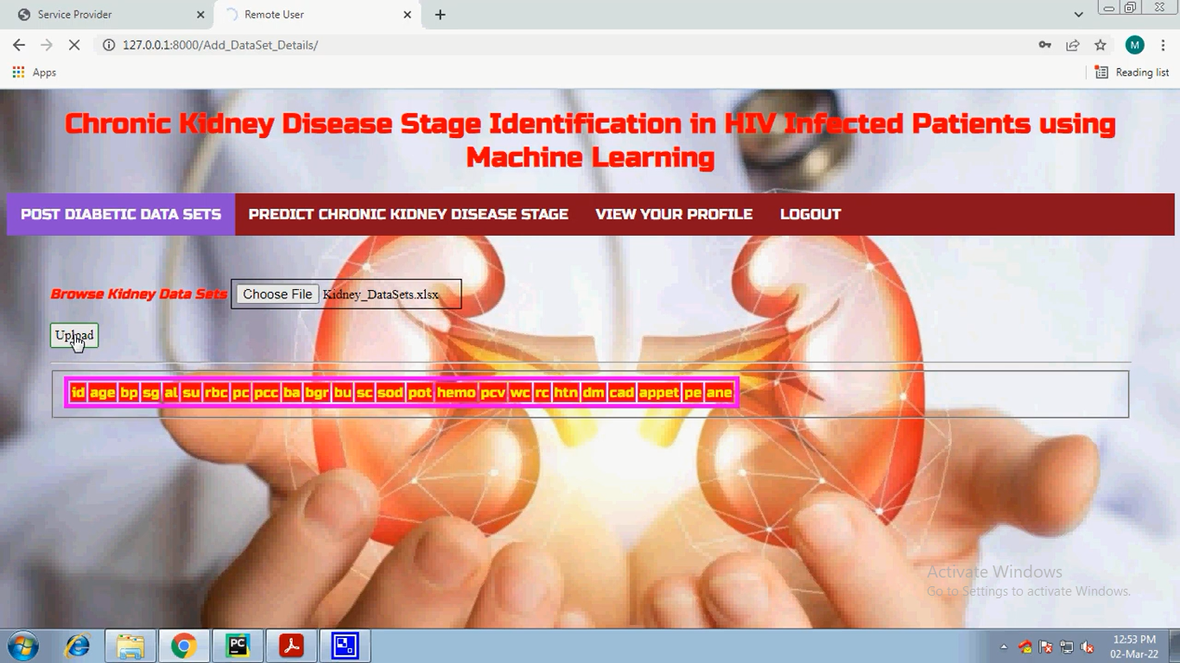

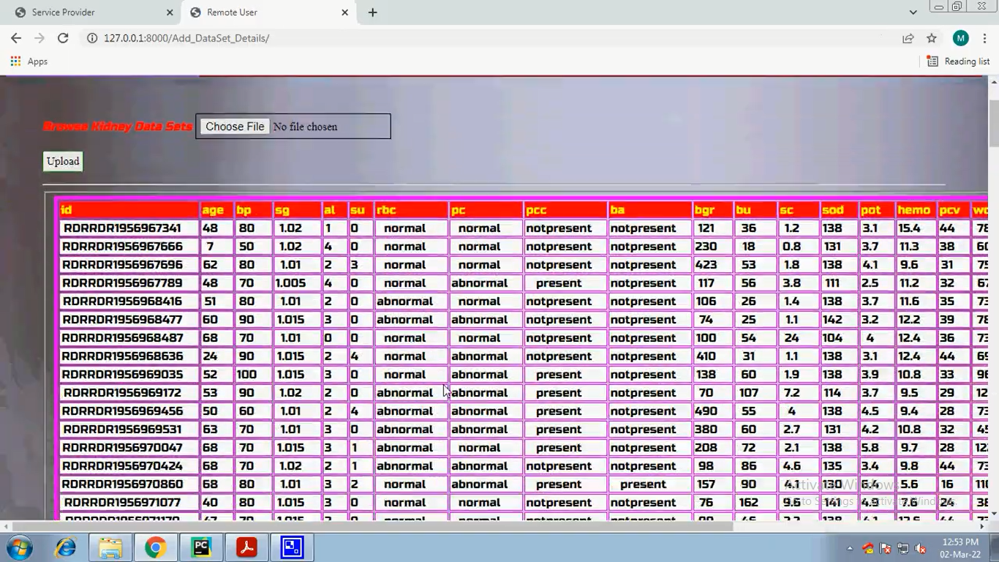

**Fig17**: patients details

Patients' details, such as their ID, age, sp, bp, al, su, rbc, pc, pcc, ba, bgr, bu, sc, sod, pot,hemo, pcv, wc, rc, htn, dm, and so on, will appear after the file is uploaded. This indicates if the patient's condition is normal or abnormal

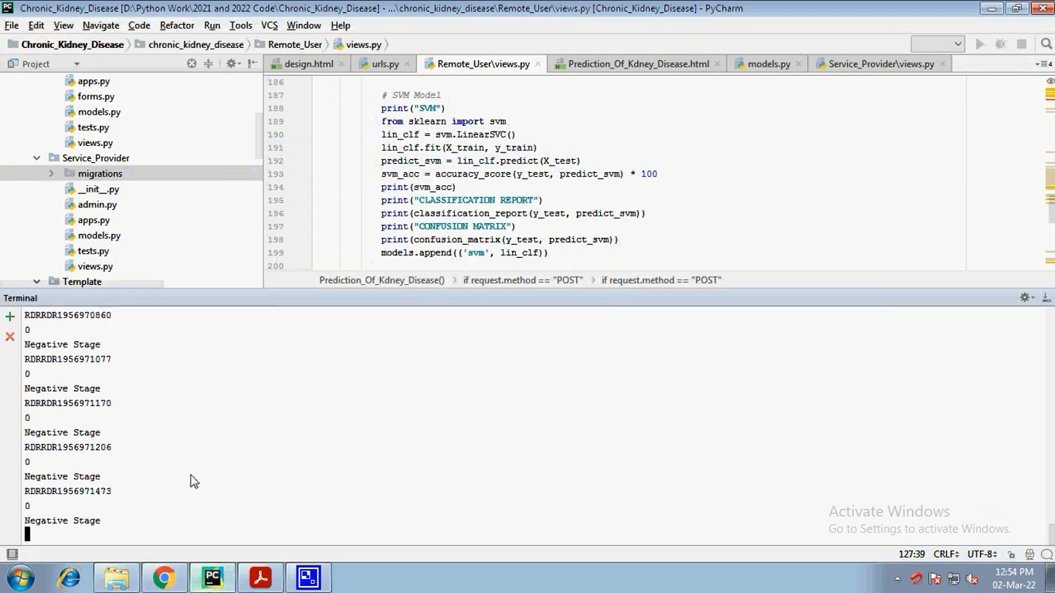

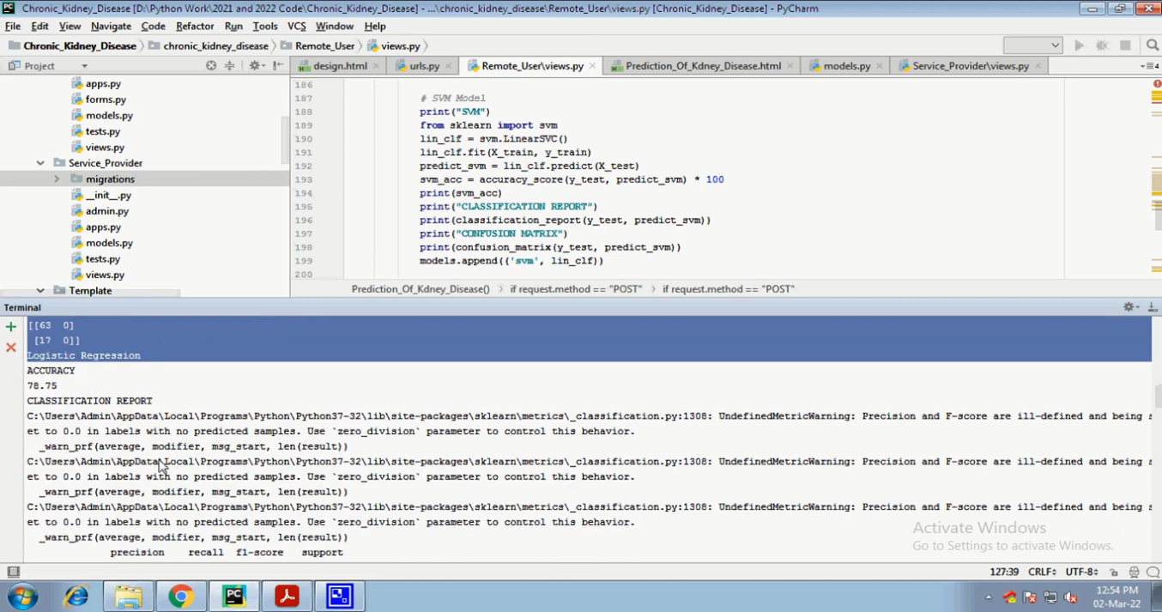

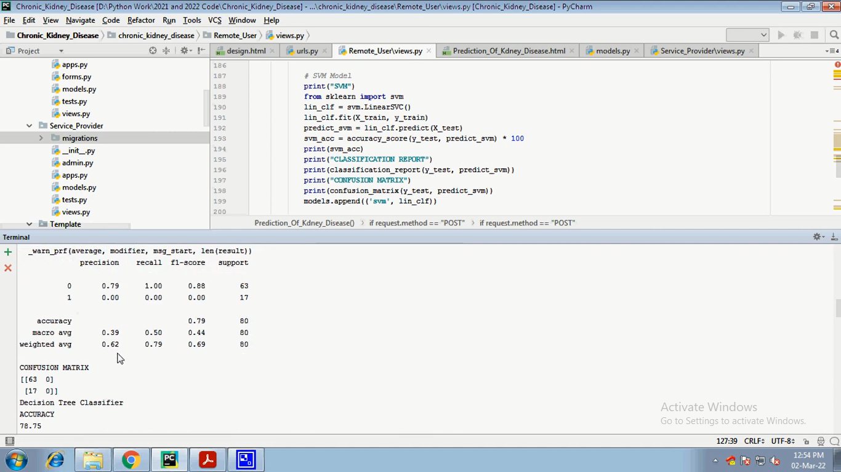

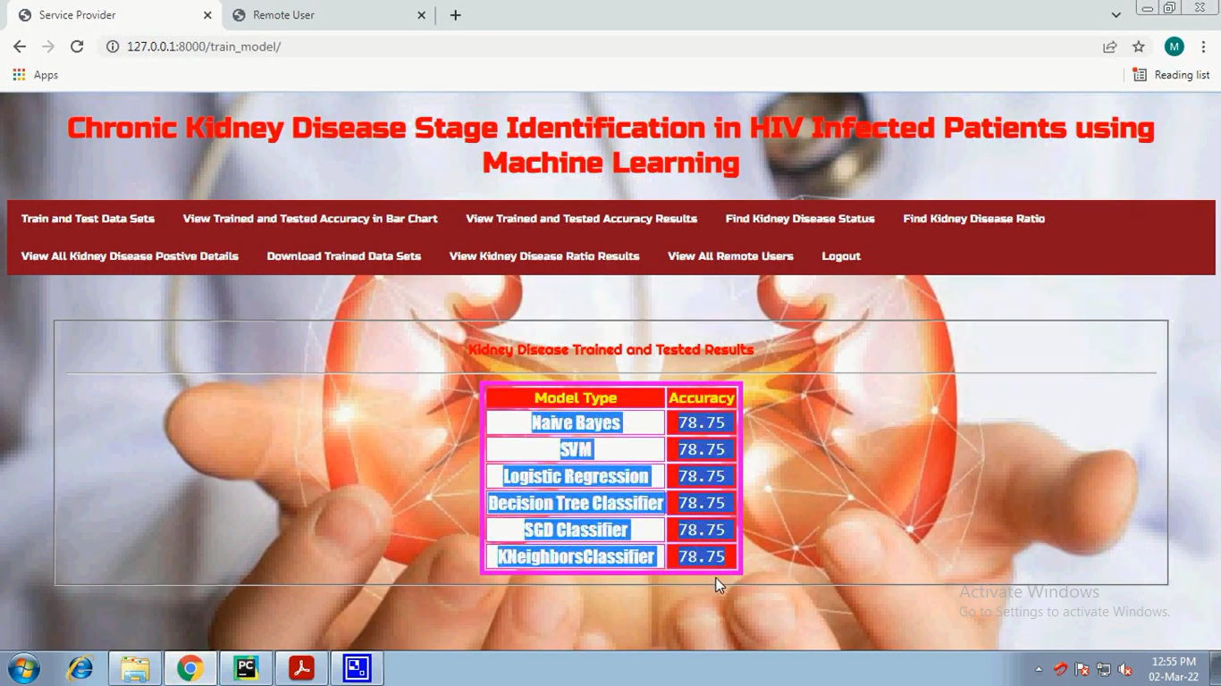

**Fig18**: Trained and Tested Results

The precision of the patient reports is provided by the model type algorithms used in these tested outcomes.

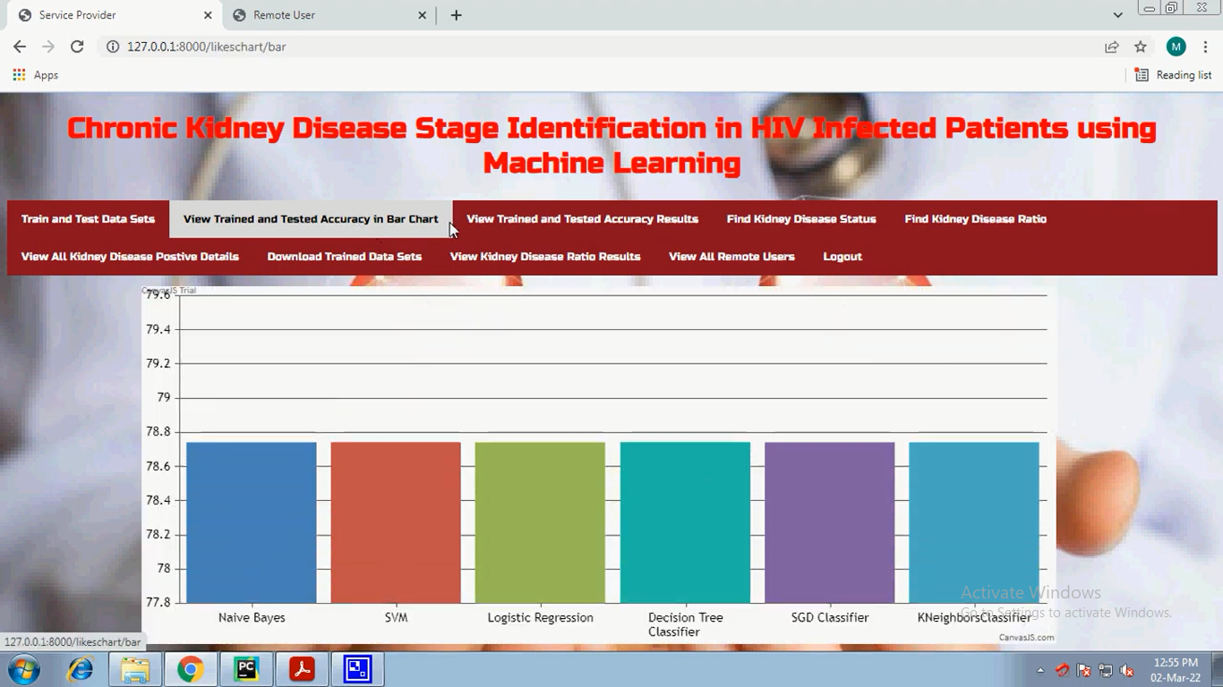

**Fig19**: View Trained and Tested Accuracy in Bar Chart

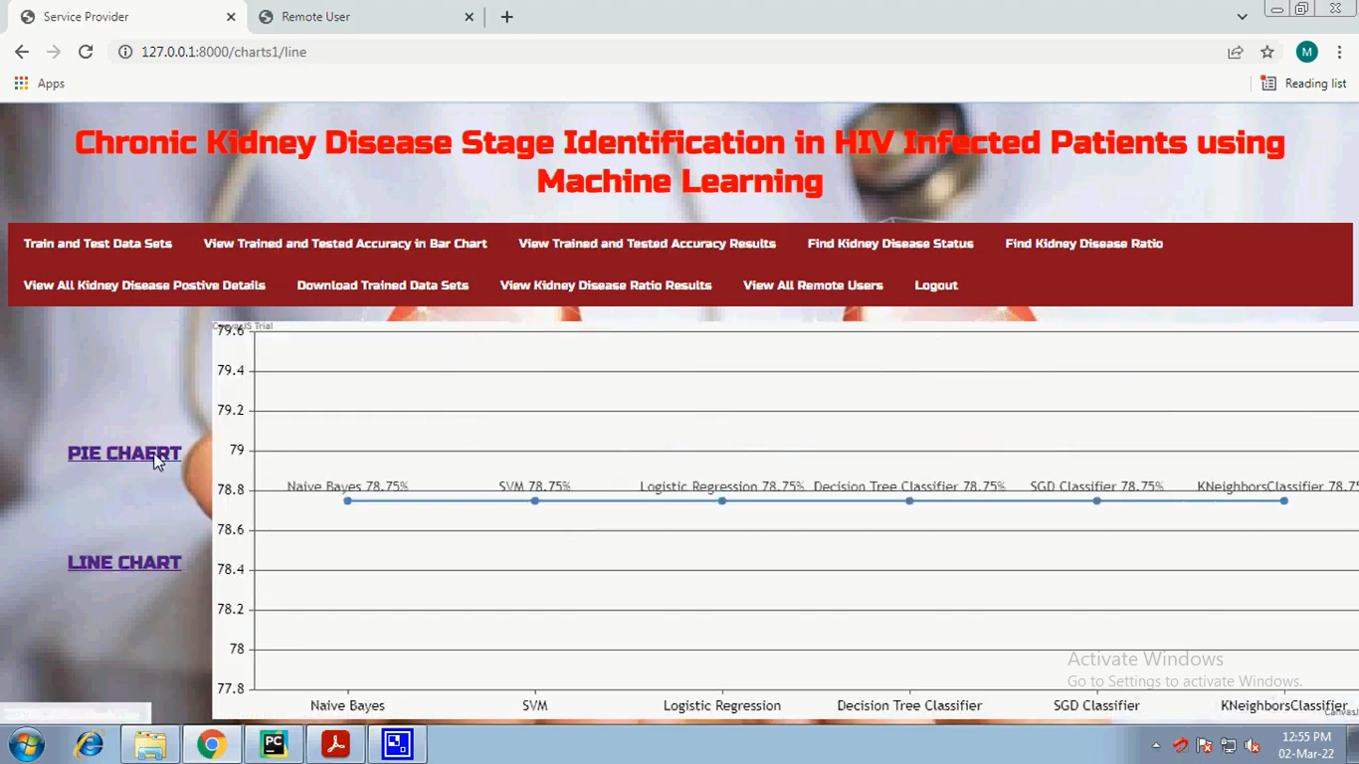

**Fig20**: View Trained and Tested Accuracy in Line Chart

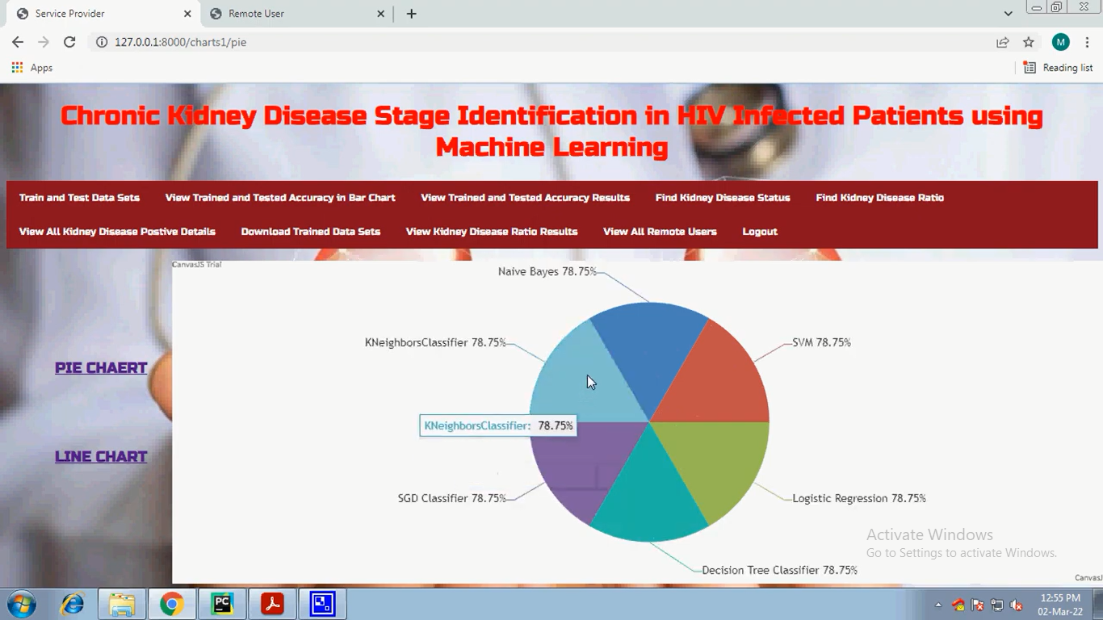

**Fig21**: View Trained and Tested Accuracy in Pie Chart

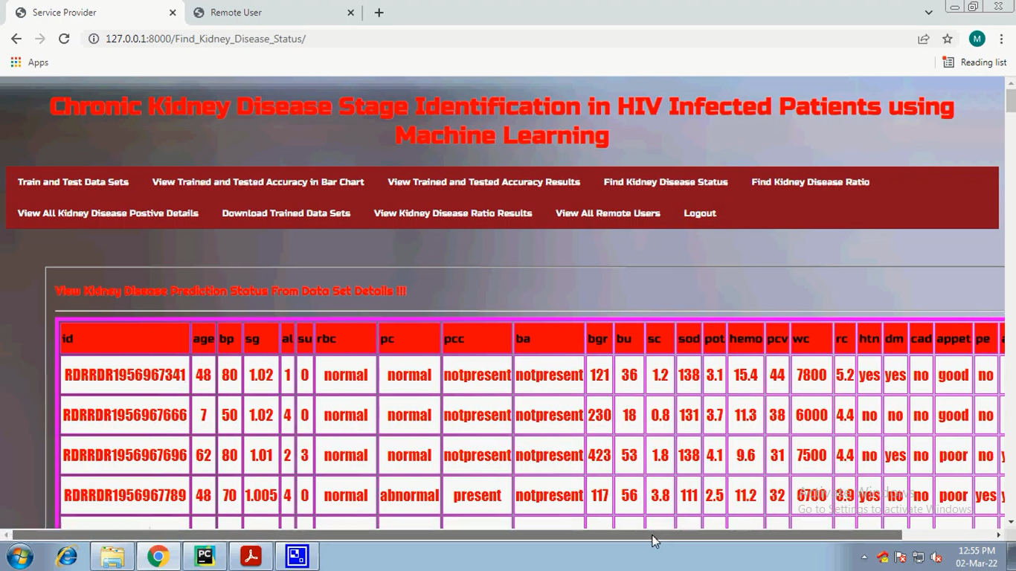

**Fig22**: Kidney disease prediction status

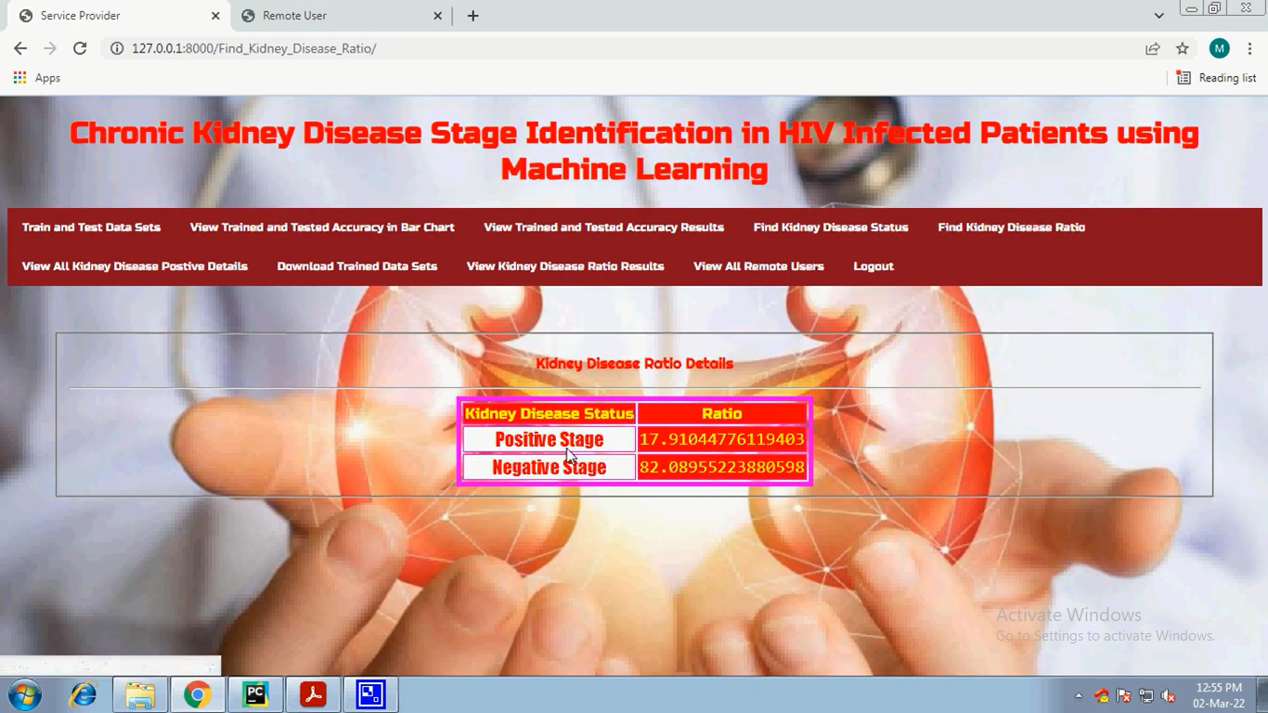

**Fig23**: Kidney disease ratio details